Decision Tree

Part 1: Signal with corruption
Filter
Output
Metric

Part 2a: ELDP 3: Block diagram of ELDP box
Input/out (no fix) the 4
Proff that ELDP 3 has three bins
Sample of an “x” in a main bin
Next bin blow up and “x” put in a second bin
Outputs
Metrics
Filter
New Output

Part 2b: ELSD 1-2: Proff of number of bins and width for both parts
Outputs
Metrics

Part 1
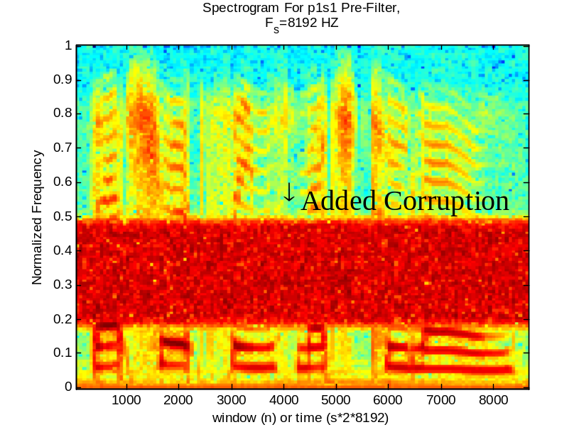

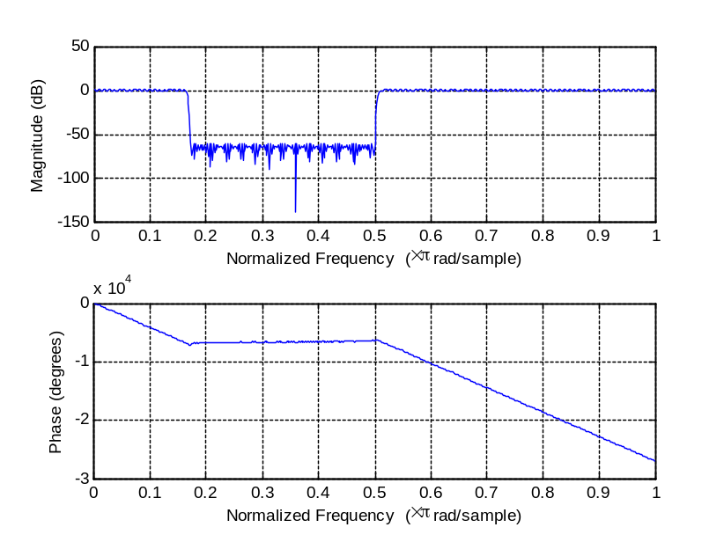

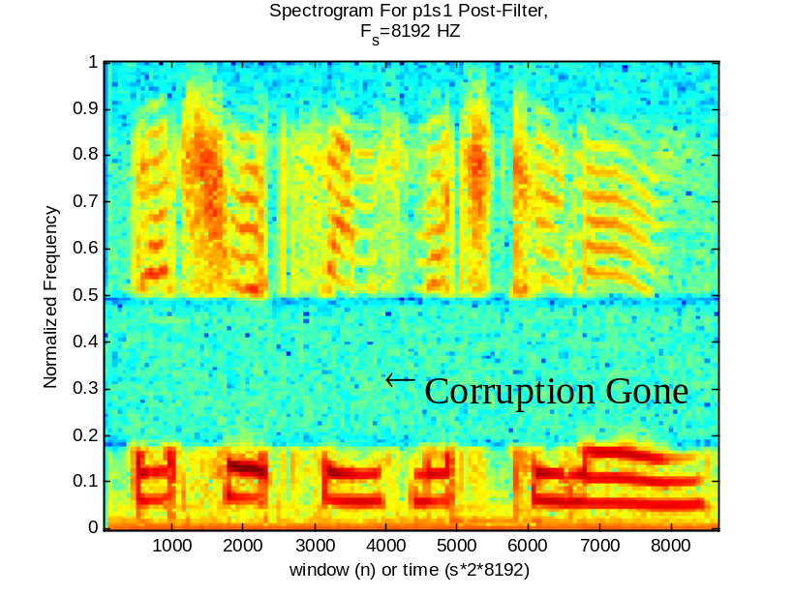

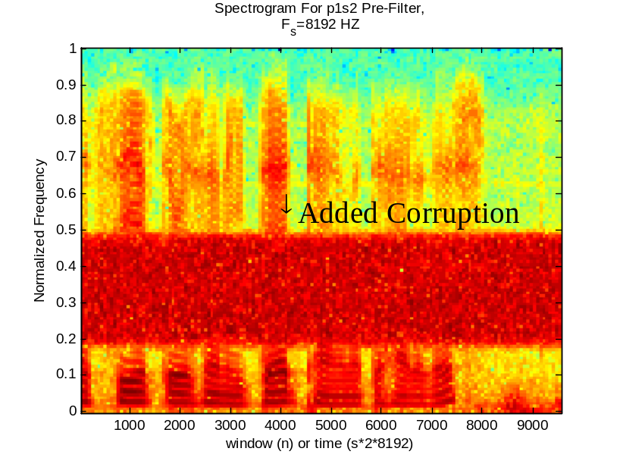

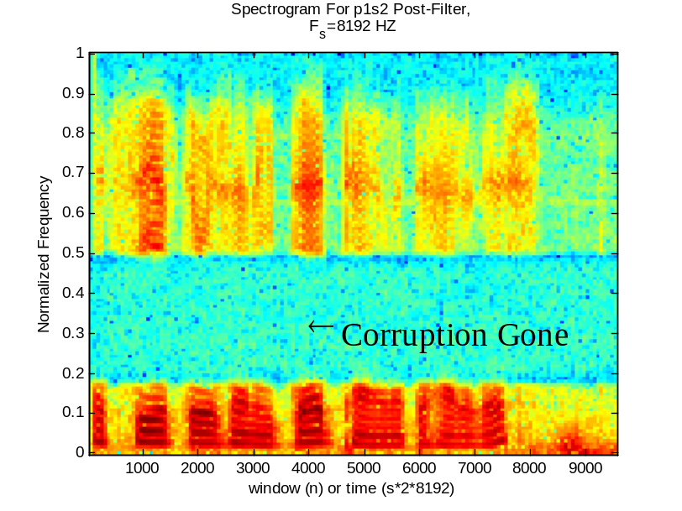

Part 2 (ELDP 1-3)

